DAY 4 -> 14-05-2026
Project 1: Customer Churn Prediction & Lifetime Value (LTV) Engine
Data Ingestion & Exploratory Data Analysis (EDA)
DONE BY -> ANANTHARAJAN V B
DATA CLEANING BASICS

cmd -> df.isnull().sum()
use -> Checks the number of missing (null) values in each column. Helps identify columns that require cleaning before analysis or modeling.
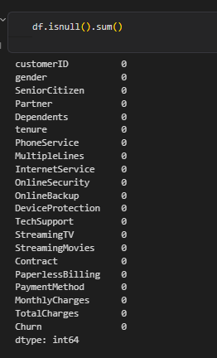

2) cmd -> df.isna().sum()
use -> Performs the same missing value check as isnull(). Useful for validating and cross-checking missing data counts.
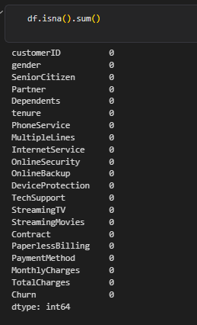
3) cmd -> (df.isnull().sum() / len(df)) * 100
use -> Calculates the percentage of missing values in each column. Helps determine whether missing data should be removed, imputed, or investigated further.

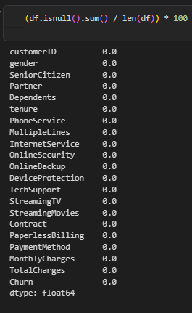

4) cmd -> df[df['TotalCharges'] == ' ']
use -> Detects hidden blank spaces that are not counted as missing values by Pandas. Important for finding data quality issues that appear as empty strings.

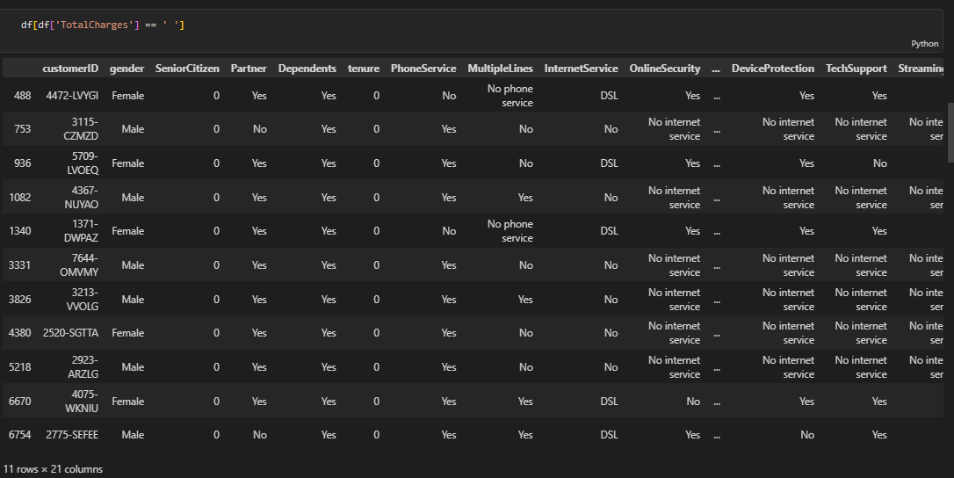

5) cmd -> df['TotalCharges'].str.strip()
use -> Removes unwanted leading and trailing spaces from text values. Ensures cleaner data and prevents datatype conversion issues.
6) cmd -> df['TotalCharges'].replace('', np.nan)
use -> Converts blank strings into proper missing values (NaN). Allows Pandas to recognize and handle missing data correctly.
7) cmd -> df.isnull().sum()
use -> Rechecks missing values after cleaning. Confirms whether hidden blanks were successfully converted into NaN values.

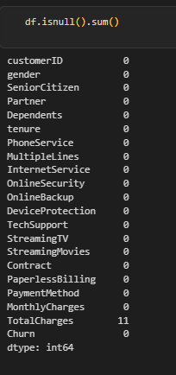

8) cmd -> df.duplicated().sum()
use -> Counts duplicate rows in the dataset. Helps identify repeated records that may affect analysis and model performance.
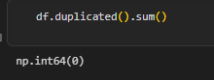
9) cmd -> df[df.duplicated()]
use -> Displays the actual duplicate records found in the dataset. Useful for inspecting and deciding whether duplicates should be removed.

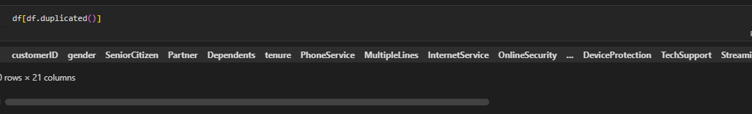
10)
cmd -> df['Contract'].value_counts()
use -> Displays the frequency of each Contract category. Helps understand category distribution and customer behavior patterns.

cmd -> df['PaymentMethod'].value_counts()
use -> Shows how customers are distributed across different payment methods. Useful for business and churn analysis.

cmd -> df['InternetService'].value_counts()
use -> Displays the count of each internet service type. Helps understand customer service preferences.

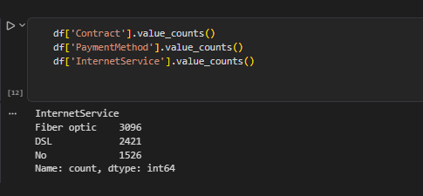

11) cmd -> df.dtypes
use -> Shows the datatype of every column in the dataset. Helps identify columns that require datatype correction.
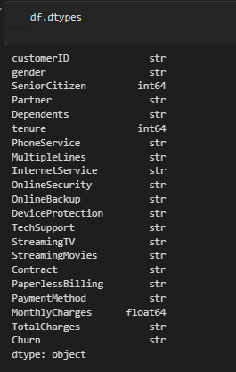

12) cmd -> pd.to_numeric(df['TotalCharges'])
use -> Converts TotalCharges from object datatype to numeric datatype. Required for numerical analysis, visualization, and machine learning.

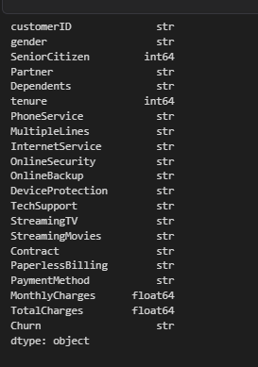

13) cmd -> df.to_csv(...)
use -> Saves the cleaned dataset to the processed data folder. Creates a reusable version that will be loaded in all future project stages.
